Q1 and Q2)

Create Database Assignment_1

--1

Create Table DEPARTMENTS(

ID int,

Name varchar(25)

);

insert into DEPARTMENTS

Values(1226557,'Ahmed Javed'),

(1234567,'Ali Muhammad'),

(1111111,'Ibrahim Dar');

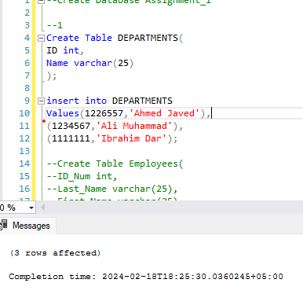

Q3)

Create Table Employee(

ID_Num int,

Last_Name varchar(25),

First_Name varchar(25),

Dept_ID int

); 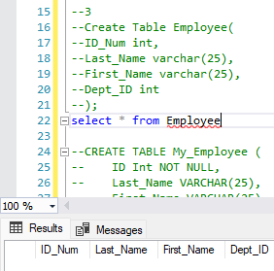

Q4 and Q5)

CREATE TABLE My_Employeee (

ID Int NOT NULL,

Last_Name VARCHAR(25),

First_Name VARCHAR(25),

UserID VARCHAR(8),

Salary DECIMAL(9, 2),

PRIMARY KEY (ID)

);

insert into My_Employeee

Values(1,'Patel','Ralph','rpatel',795);



Q6)

Insert into My_Employeee(ID,Last_Name,First_Name,UserID,Salary)

Values(2,'Dancs','Betty','bdancs',860);

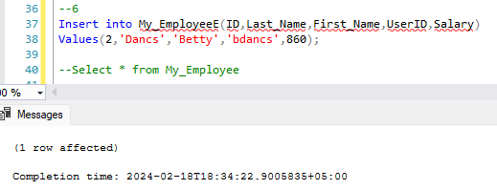

Q7)

Select * from My_Employeee

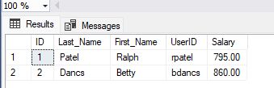

Q8 and Q9)

UPDATE My_Employeee

SET Last_Name = 'Hammad'

WHERE Last_Name = 'Dancs';

--9

Update My_Employeee

Set Salary=3000

WHERE (First_Name LIKE '%t%' OR Last_Name LIKE '%t%')

AND Salary BETWEEN 500 AND 2000;

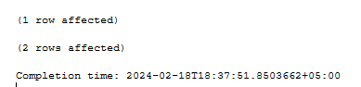

Q10)

Delete from My_Employeee

where Salary>5000

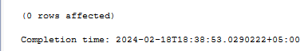

Q11)

Create Table MYDEPT1_L226557(

Department_ID INT Primary Key,

Name varchar(25),

Location varchar(15)

);

Create Table MYEMP1_L226557(

ID int Primary Key,

Name varchar(25),

DEPT_ID int Foreign Key References MYDEPT1_L226557(Department_ID)

);

SELECT* FROM MYDEPT1_L226557

SELECT* FROM MYEMP1_L226557

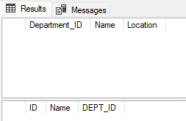

Q12)

ALTER TABLE MYEMP1_L226557

ALTER COLUMN Name VARCHAR(50);

ALTER TABLE MYDEPT1_L226557

ALTER COLUMN Name VARCHAR(50);

EXEC sp_columns 'MYEMP1_L226557';

SELECT COLUMN_NAME, DATA_TYPE, CHARACTER_MAXIMUM_LENGTH

FROM INFORMATION_SCHEMA.COLUMNS

WHERE TABLE_NAME = 'MYDEPT1_L226557';

SELECT COLUMN_NAME, DATA_TYPE, CHARACTER_MAXIMUM_LENGTH

FROM INFORMATION_SCHEMA.COLUMNS

WHERE TABLE_NAME = 'MYEMP1_L226557';

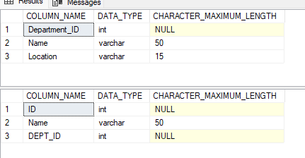

Q13)

ALTER TABLE MYEMP1_L226557

ALTER COLUMN ID numeric(18,0);

-- Confirm modification

SELECT * FROM MYEMP1_L226557;



Q14)

INSERT INTO MYDEPT1_L226557

Values(111,'CS','BLOCK C'),

(112,'EE','BLOCK D'),

(113,'CIVL', 'BLOCK A'),

(114,'MANAGEMENT', 'BLOCK B');



Q15)

INSERT INTO MYEMP1_l226557

VALUES(226557,'Ahmed Javed',100);

--cant insert as dept id is foreign key and i gave foreign key 111 for CS whereas here it is 100



Q16)

EXEC sp_rename 'MYEMP1_L226557', 'EMP1_L226557'

EXEC sp_rename 'MYDEPT1_L226557', 'DEPT1_L226557'

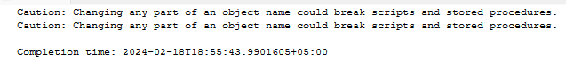

Q17)

ALTER TABLE DEPT1_L226557

DROP COLUMN Name;

SELECT COLUMN_NAME, DATA_TYPE, CHARACTER_MAXIMUM_LENGTH

FROM INFORMATION_SCHEMA.COLUMNS

WHERE TABLE_NAME = 'DEPT1_L226557';

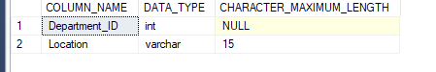

Q18)

DROP TABLE EMP1_L226557;

SELECT COLUMN_NAME, DATA_TYPE, CHARACTER_MAXIMUM_LENGTH

FROM INFORMATION_SCHEMA.COLUMNS

WHERE TABLE_NAME = 'EMP1_L226557';

SELECT *FROM EMP1_L226557

